Corp Container Component

Once we add a Corp container component, it automatically shows one container inside that to add or drag any component to design the Corp container.

For e.g. Text, images, videos, button

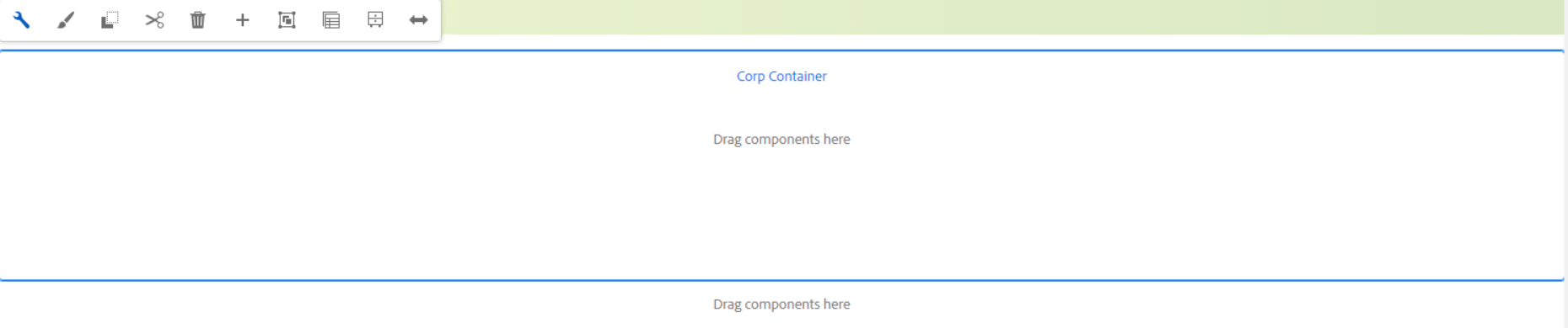

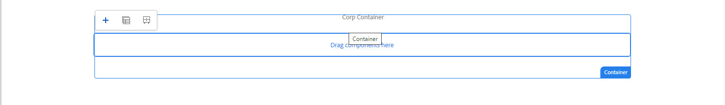

Properties Tab

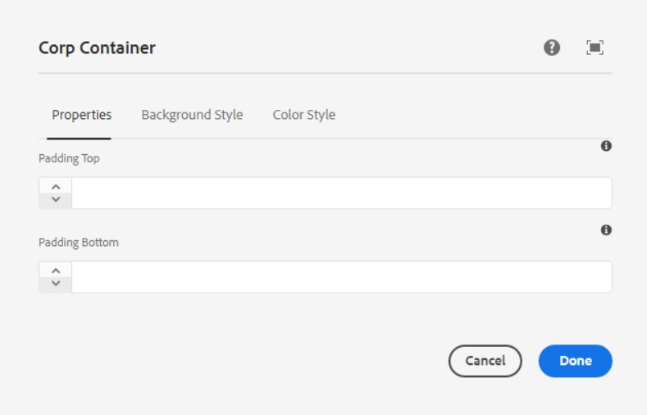

**Padding Top** – Here we can add a padding-top for the Corp container. It will be added in PX.

**Padding Bottom** – Here we can add a padding-bottom for the Corp container. It will be added in PX.

___________________________________________________________________

Background Style Tab

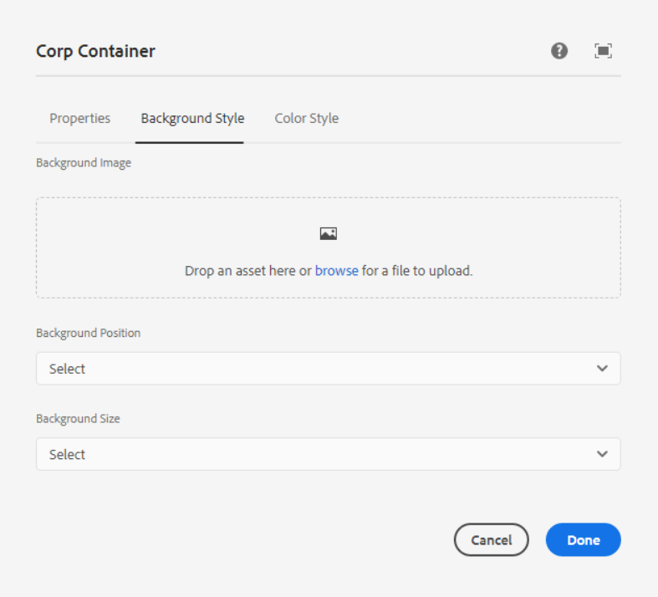

**Background Image** – Here we can edit, clear or pick any image as per the requirement.

**Background Position** – In this dropdown below list of positions are available, we can select one position as per our requirement.

1. Bottom Left

- background-position: 0px 0px, 50% 50%;

2. Bottom Center

- background-position: 0px 0px, 50% 0%;

3. Bottom Left center

- background-position: 0px 0px, 100% 50%;

4. Bottom

- background-position: 0px 0px, 100% 0%;

5. Bottom left right

- background-position: 0px 0px, 50% 20%;

6. Right bottom

- background-position: 0px 0px, 100% 50%, 0px 0px;

7. center top

- background-position: 50% 25%;

8. Center small

- background-position: 50% 0%;

9. Left Center

- background-position: 8% 50%;

10. Right crop

- background-position: 50% -85px;

**Background Cover** – In this dropdown below list of position are available, we can select one position as per our requirement.

1. Background Cover

background-size: auto, cover;

1. Background Half Cover

background-size: auto, 50%, auto;

1. Background Full Cover

background-size: cover;

___________________________________________________________________

Color Style Tab

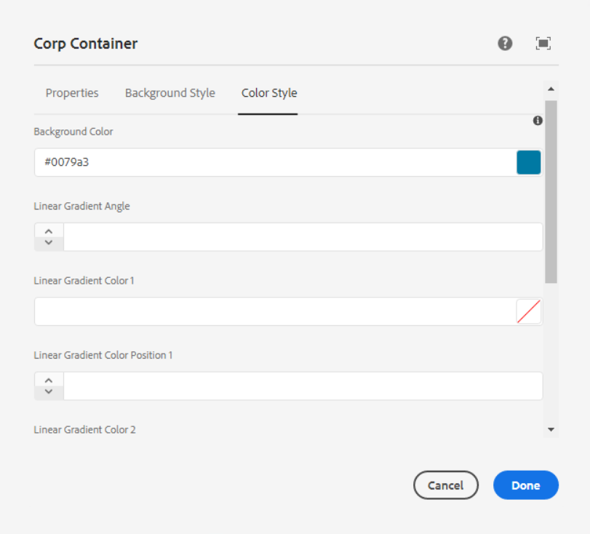

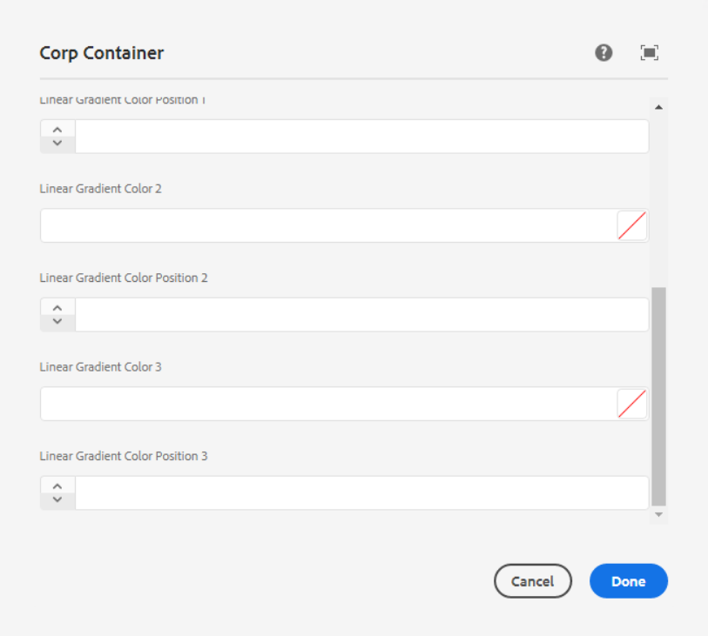

**Background Color** – Pick any color as per our requirement in hex or RGBA format.

**Linear Gradient Angle** – Here we can set the angle of the background Image

**Liner Gradient Color and Liner Gradient Color Position** – Here we have 3 options to add color and position.

___________________________________________________________________

Style options

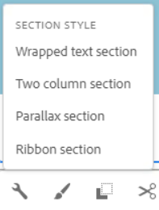

**Section Style** – Here we can select one style as per our requirement

1. **Wrapped Text Section**

Page Reference - <https://www.ancestry.com/corporate/family-history-month>

AEM URL - <https://author-ancestry-dev2.adobecqms.net/content/ancestry-corp/us/en/family-history-month.html?wcmmode=disabled>



1. **Two Column Section**

Page Reference - <https://www.ancestry.com/corporate/contact>

AEM URL - <https://author-ancestry-dev2.adobecqms.net/content/ancestry-corp/us/en/contact.html?wcmmode=disabled>



1. **Parallax Section**

Page Reference - <https://www.ancestry.com/corporate/newsroom/in-the-new>

AEM URL - <https://author-ancestry-dev2.adobecqms.net/content/ancestry-corp/us/en/newsroom/in-the-news.html?wcmmode=disabled>

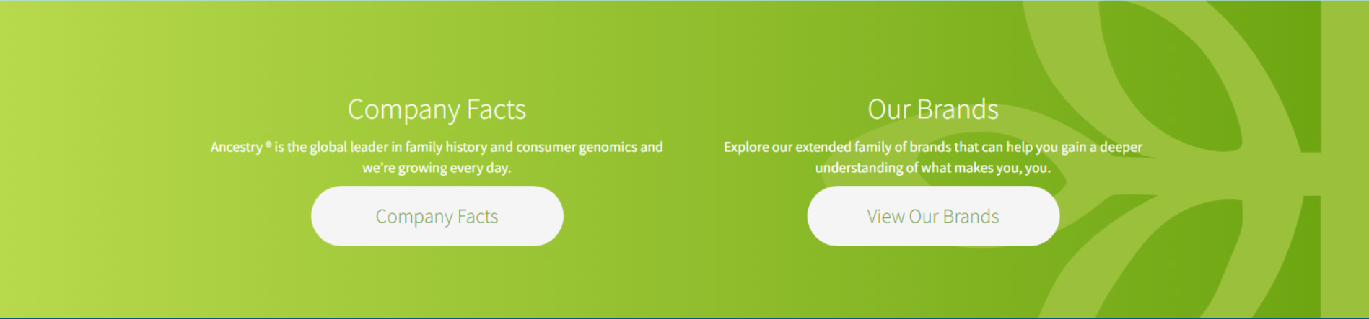

1. **Ribbon Section**

Page Reference - <https://www.ancestry.com/corporate/corporate-responsibility>

AEM URL - <https://author-ancestry-dev2.adobecqms.net/content/ancestry-corp/us/en/corporate-responsibility.html?wcmmode=disabled>



___________________________________________________________________

Page References without style options

* [**https://www.ancestry.com/corporate/about-ancestry/our-story**](https://www.ancestry.com/corporate/about-ancestry/our-story)



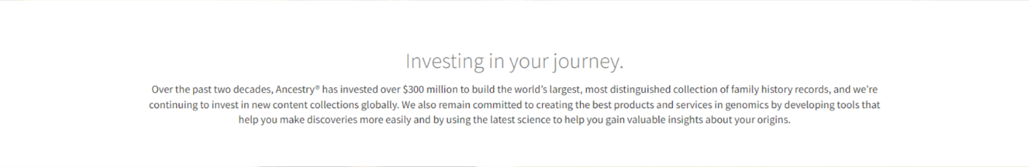

* [**https://www.ancestry.com/corporate/newsroom/in-the-news**](https://www.ancestry.com/corporate/newsroom/in-the-news)



* [**https://www.ancestry.com/corporate/photo-library**](https://www.ancestry.com/corporate/photo-library)



* [**https://www.ancestry.com/corporate/au**](https://www.ancestry.com/corporate/au)



* [**https://www.ancestry.com/corporate/corporate-responsibility**](https://www.ancestry.com/corporate/corporate-responsibility)

